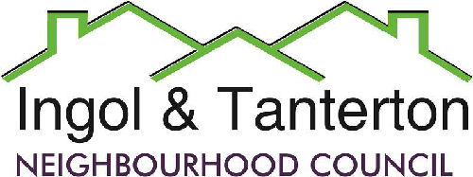
Gill Mason - Clerk and RFO
Email: ingoltantertonnc@hotmail.co.uk
Agenda
All parish councillors are hereby summoned to the annual meeting of Ingol and Tanterton Neighbourhood Council on Wednesday 22nd May 2024 at 7.00pm at Tanterton Village Centre.

Open forum

1.To receive apologies.

2.To approve the minutes of the meeting held on Wednesday 17th April 2024.

3.To receive declarations of interest.

4.Election of chair for 2024/2025

5.Election of vice- chair for 2024/2025.

6.To consider planning applications, reports and matters.
LCC Highways update on Brighton Crescent one way street request.

7.Finance.
Expenditure
BACS | MB Landscaping | Lengthsman’s basic plus extra hours(3) | £624.00
BACS | Gill Mason – clerk | Monthly expenses | £33.24
BACS | British Gas | Cottam Gate electrics | £71.96
BACS | Zurich | Insurance | £649.66
BACS | Easywebsites | Website transfer and redesign | £600.00
BACS | Community Gateway | Valuation fees | £300.00

8.To consider the lengthsman’s update and schedule of works.

9.To consider the green spaces agreement with Preston City Council and review the schedule.

10.To consider the clerk’s office laptop and mobile.

11.To consider the speeding issues on Tanterton Hall Road and the siting of the SpiD.

12.To receive an update on Area Enhancement projects
- Ingol Dip
- Tanterton football pitch barrier

13.Reports and correspondence.

14.Date and time of meetings.

Press and public are welcome to attend.

